Server : 80.241.215.197,1060
Database Name : byte_maxwello
Username : byte_maxwello
Password: M8jc11p^5

Employee can only enter his vacation.
history of employees Vacation should be maintained

Check in Company table if company WeekEndSkip than number of days should skip weekend (week end not count in Vacation) no need to enter any thing just you need to check from this table
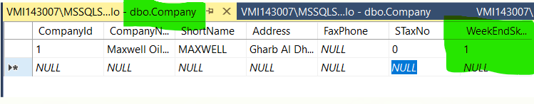

Vacation Request Form should have the following Field once its approved or rejected it should not be updated.
Table Name VacationRequest (you need to insert data in this table)
SP: SP_INSERT_VacationRequest, SP_Usdate_VacationRequest, SP_Select_VacationRequest
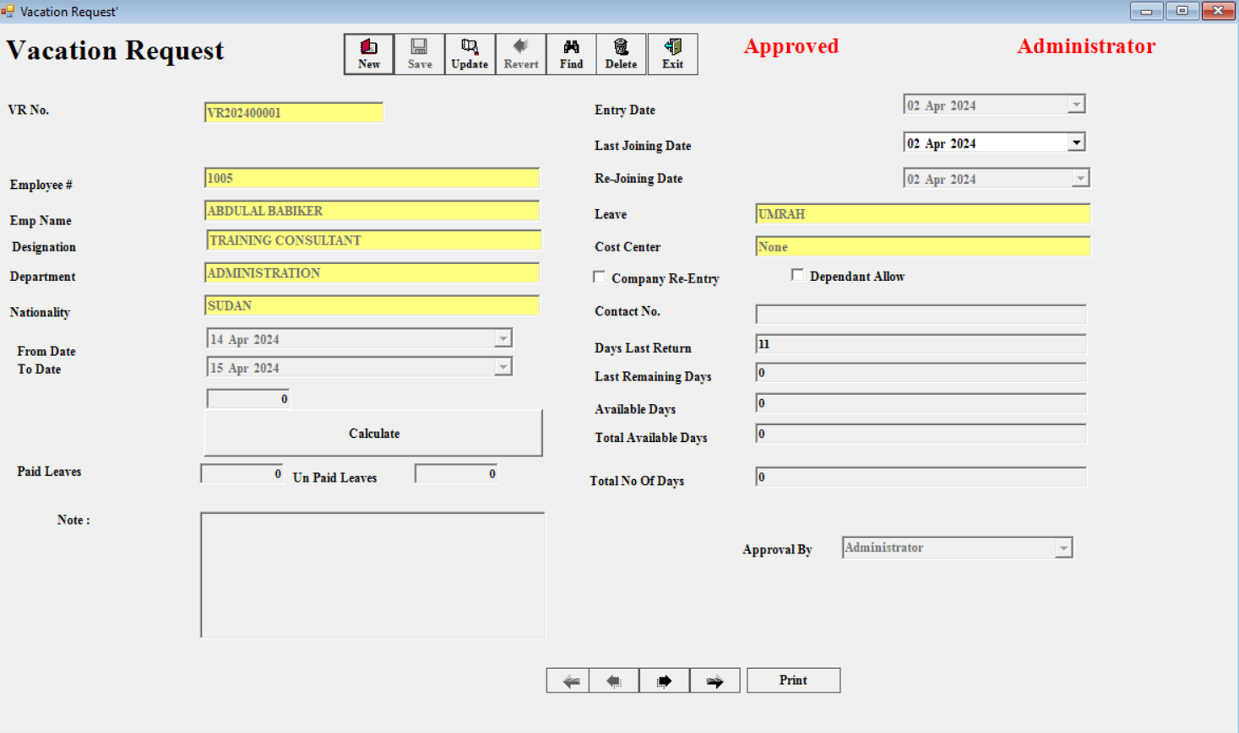
Vacation request have multiple approval once its entered it should email to First approval if its approved by first Approval than email generated to user and 2nd approval if there are multiuser approval other wise it can be use in Vacation form.

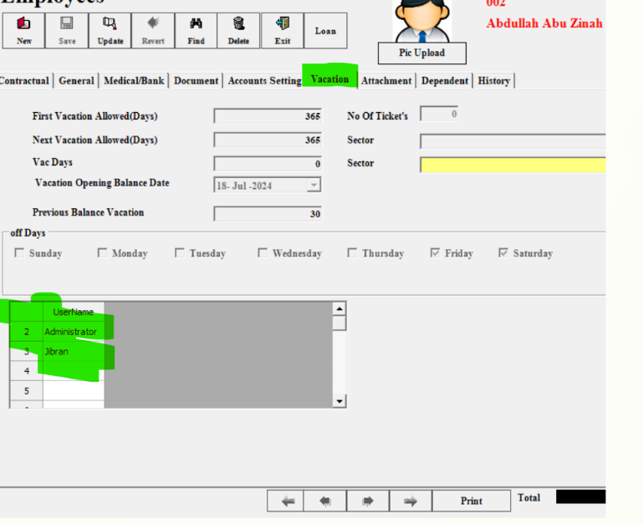
User can only see there own approval

Table Name : Approval,
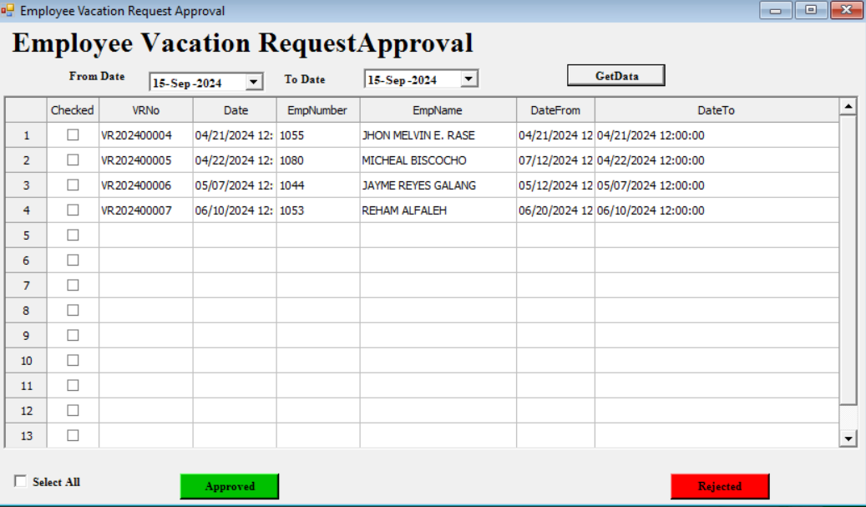

If user approved or reject.
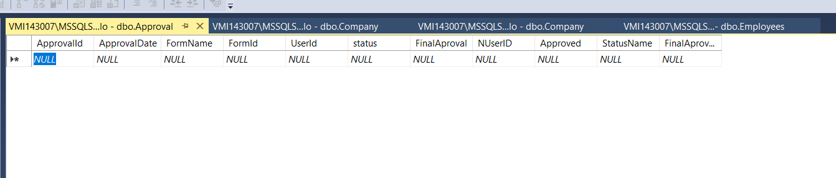
ApprovalID is Autogenerated AprovalDate, FormName should be Provided should be FormID is VacationRequestID ,status should be 1 if Final approved otherwise it should be 0,NuserID should be next users ID for approval when.
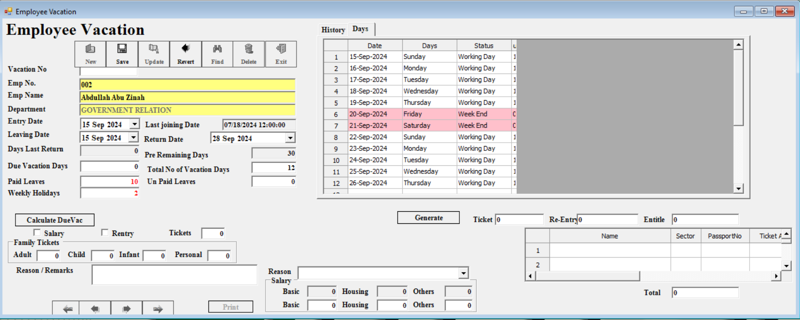

Table and Store procedure Script

CREATE TABLE [dbo].[VacationRequest](
[VRID] [int] IDENTITY(1,1) NOT NULL,
[VRNo] [nvarchar](50) NULL,
[VRDate] [date] NULL,
[EmpId] [int] NULL,
[DesignationID] [int] NULL,
[DepartmentID] [int] NULL,
[CostId] [int] NULL,
[LeaveId] [int] NULL,
[AULeave] [nvarchar](500) NULL,
[DateFrom] [date] NULL,
[DateTo] [date] NULL,
[NofDays] [nvarchar](500) NULL,
[JoiningDate] [date] NULL,
[PaidDays] [nvarchar](500) NULL,
[UnPaidDays] [nvarchar](500) NULL,
[CREentry] [decimal](18, 2) NULL,
[ECNo] [nvarchar](500) NULL,
[DependantAllow] [decimal](18, 2) NULL,
[Cancel] [decimal](18, 2) NULL,
[Approved] [decimal](18, 2) NULL,
[NationalityId] [int] NULL,
[UserId] [int] NULL,
[Note] [nvarchar](500) NULL,
[LeaveName] [nvarchar](500) NULL,
[CostName] [nvarchar](50) NULL,
[DayssLReturn] [nvarchar](500) NULL,
[PreRemaingDays] [nvarchar](500) NULL,
[LastVacationReturn] [date] NULL,
[TotalAvlDays] [nvarchar](500) NULL,
[AvailableDays] [nvarchar](500) NULL,
[ContactNo] [nvarchar](50) NULL,
[ApprovalID] [int] NULL,
[ApplyForApproval] [int] NULL,
CONSTRAINT [PK_VacationRequest] PRIMARY KEY CLUSTERED
(
[VRID] ASC
)WITH (PAD_INDEX = OFF, STATISTICS_NORECOMPUTE = OFF, IGNORE_DUP_KEY = OFF, ALLOW_ROW_LOCKS = ON, ALLOW_PAGE_LOCKS = ON ) ON [PRIMARY]
) ON [PRIMARY]
GO
ALTER TABLE [dbo].[VacationRequest] ADD CONSTRAINT [DF_VacationRequest_ApplyForApproval] DEFAULT ((0)) FOR [ApplyForApproval]
GO
ALTER TABLE [dbo].[VacationRequest] WITH CHECK ADD CONSTRAINT [FK_VacationRequest_Employees] FOREIGN KEY([EmpId])
REFERENCES [dbo].[Employees] ([EmpID])
GO
ALTER TABLE [dbo].[VacationRequest] CHECK CONSTRAINT [FK_VacationRequest_Employees]
GO
/****** Object: StoredProcedure [dbo].[SP_INSERT_VacationRequest] Script Date: 09/15/2024 06:17:19 ******/
SET ANSI_NULLS ON
GO
SET QUOTED_IDENTIFIER ON
GO
CREATE procedure [dbo].[SP_INSERT_VacationRequest]

@VRID int = null,
@VRNo nvarchar (100) = null,
@VRDate date = null,
@EmpId int = null,
@DesignationID int = null,
@DepartmentID int = null,
@CostId int = null,
@LeaveId int = null,
@AULeave nvarchar (100) = null,
@DateFrom date = null,
@DateTo date = null,
@NofDays nvarchar (499) = null,
@JoiningDate date = null,
@PaidDays nvarchar (499) = null,
@UnPaidDays nvarchar (499) = null,
@CREentry decimal(18,2) = null,
@ECNo nvarchar(499) = null,
@DependantAllow decimal(18,2) =null,
@Cancel decimal(18,2) =null,
@Approved decimal(18,2) =null,
@NationalityId int = null,
@UserId int = null,
@Note nvarchar (499) = null,
@LeaveName nvarchar(499) = null,
@CostName nvarchar(100) = null,
@DayssLReturn nvarchar(499) = null,
@PreRemaingDays nvarchar(499) = null,
@LastVacationReturn nvarchar(499) = null,
@TotalAvlDays nvarchar(499) = null,
@AvailableDays nvarchar(499) = null,
@ContactNo nvarchar(100) = null,
@ApprovalID int =null

as
declare @id int

declare @strYear int
set @strYear = Year(@VRDate)

set @VRNo = 'VR' + Right(str(@strYear),4)
select @id = Isnull(Max(Cast(Right(VRNo,5) as int))+1,1) from VacationRequest
where VRNo Like @VRNo + '%'
set @VRNo = @VRNo + Replace(str(@id,5),' ','0')

insert into VacationRequest(

VRNo,
VRDate,
EmpId,
DesignationID,
DepartmentID,
CostId,
LeaveId,
AULeave,
DateFrom,
DateTo,
NofDays,
JoiningDate,
PaidDays,
UnPaidDays,
CREentry,
ECNo,
DependantAllow,
Cancel,
Approved,
NationalityId,
UserId,
Note,LeaveName,CostName,DayssLReturn,PreRemaingDays,LastVacationReturn,TotalAvlDays,AvailableDays,ContactNo,ApprovalID ,ApplyForApproval) values (

@VRNo,
@VRDate,
@EmpId,
@DesignationID,
@DepartmentID,
@CostId,
@LeaveId,
@AULeave,
@DateFrom,
@DateTo,
@NofDays,
@JoiningDate,
@PaidDays,
@UnPaidDays,
@CREentry,
@ECNo,
@DependantAllow,
@Cancel,@Approved,@NationalityId,@UserId,@Note,@LeaveName,@CostName,@DayssLReturn,@PreRemaingDays,@LastVacationReturn,@TotalAvlDays,@AvailableDays,@ContactNo,@ApprovalID,0 )
GO
/****** Object: StoredProcedure [dbo].[SP_SELECT_ALL_VacationRequest] Script Date: 09/15/2024 06:17:19 ******/
SET ANSI_NULLS ON
GO
SET QUOTED_IDENTIFIER ON
GO
CREATE procedure [dbo].[SP_SELECT_ALL_VacationRequest]
as
select VRID,VRNo,VRDate,
EmpId,
(Select EmpNumber from Employees where EMpid=M.Empid) as EmpNumber,(Select EmpName from Employees where EMpid=M.Empid) as EmpName,
DesignationID,
(Select DesignationName from Designation where DesignationID =M.DesignationID) as DesignationName,
DesignationID,
DepartmentID,
(Select DepartmentName from Department where DepartmentId=m.DepartmentID) as DepartmentName,
CostId,
(Select CostName from CostCenter where CostId=m.CostId) as CostName,
LeaveId,
(Select LeaveName from Leaves where LeaveId=m.LeaveID) as LeaveName,
AULeave,DateFrom,DateTo,NofDays,JoiningDate,PaidDays,UnPaidDays,CREentry,ECNo,DependantAllow,Cancel,Approved,
NationalityId,
(Select Nationalityname from Nationality where NationalityId=m.NationalityId) as Nationalityname,
UserId,Note,LeaveName,CostName,DayssLReturn,PreRemaingDays,LastVacationReturn,TotalAvlDays,AvailableDays,ContactNo,

(Select isnull( count(ApprovalId),0) from Approval where FormName='Vacation Request' and FormId=M.VRID) as Approval,

(Select top 1 U.UserName from Approval A,Users U where A.UserID=U.UserId and FormName='Vacation Request' and FormId=M.VRID) as ApprovalUser,
ApprovalID,
ApplyForApproval

from VacationRequest M order by VRID
GO
/****** Object: StoredProcedure [dbo].[SP_UPDATE_VacationRequest] Script Date: 09/15/2024 06:17:19 ******/
SET ANSI_NULLS ON
GO
SET QUOTED_IDENTIFIER ON
GO
CREATE procedure [dbo].[SP_UPDATE_VacationRequest]
@VRID int = null,
@VRNo nvarchar (100) = null,
@VRDate date = null,
@EmpId int = null,
@DesignationID int = null,
@DepartmentID int = null,
@CostId int = null,
@LeaveId int = null,
@AULeave nvarchar (100) = null,
@DateFrom date = null,
@DateTo date = null,
@NofDays nvarchar (499) = null,
@JoiningDate date = null,
@PaidDays nvarchar (499) = null,
@UnPaidDays nvarchar (499) = null,
@CREentry decimal(18,2) = null,
@ECNo nvarchar(499) = null,
@DependantAllow decimal(18,2) =null,
@Cancel decimal(18,2) =null,
@Approved decimal(18,2) =null,
@NationalityId int = null,
@UserId int = null,
@Note nvarchar(499) = null,
@LeaveName nvarchar(499) = null,
@CostName nvarchar(100) = null,
@DayssLReturn nvarchar(499) = null,
@PreRemaingDays nvarchar(499) = null,
@LastVacationReturn date = null,
@TotalAvlDays nvarchar(499) = null,
@AvailableDays nvarchar(499) = null,
@ContactNo nvarchar(100) = null,
@ApprovalID int

as
update VacationRequest set

VRDate = @VRDate,
EmpId = @EmpId,
DesignationID = @DesignationID,
CostId = @CostId,
LeaveId = @LeaveId,
AULeave = @AULeave,
DateFrom = @DateFrom,
DateTo = @DateTo,
NofDays = @NofDays,
JoiningDate = @JoiningDate,
PaidDays = @PaidDays,
UnPaidDays = @UnPaidDays,
CREentry = @CREentry,
ECNo = @ECNo,
DependantAllow = @DependantAllow,
Cancel = @Cancel,
Approved = @Approved,
NationalityId = @NationalityId,
UserId = @UserId,
Note = @Note,
LeaveName = @LeaveName,
CostName = @CostName,
DayssLReturn = @DayssLReturn,
PreRemaingDays = @PreRemaingDays,
LastVacationReturn = @LastVacationReturn,
TotalAvlDays = @TotalAvlDays,
AvailableDays = @AvailableDays,
ContactNo = @ContactNo,
ApprovalID=@ApprovalID
where VRID = @VRID
GO
/****** Object: StoredProcedure [dbo].[UP_SELECT_ALL_VacationApproval] Script Date: 09/15/2024 06:17:19 ******/
SET ANSI_NULLS ON
GO
SET QUOTED_IDENTIFIER ON
GO
CREATE proc [dbo].[UP_SELECT_ALL_VacationApproval]

as

Select Vr.VRID,VR.VRNo ,VRDate as InvoiceDate,e.EmpNumber,E.EmpName, vr.DateFrom,VRDate from VacationRequest VR,Employees E where VR.EmpId=E.EmpID and VR.VRID not In (Select FormId from Approval where FormName='Vacation Request')
GO

